Experiment No.: 5
1.Title: Apply array methods and object handling; create a cart total calculator with discount logic in html, js, css.
2. Software/Tools Required: VSC,HTML,CSS
3. Theory:
A shopping cart application is a web-based system that demonstrates the use of HTML, CSS, and JavaScript to create an interactive e-commerce interface. HTML is used to structure the products, search bar, cart, and order summary, while CSS provides a responsive Amazon-inspired layout with a futuristic neon design. JavaScript handles the dynamic functionality using objects and arrays to store product and cart information. Array methods such as map() are used to display products and cart items, find() is used to locate products, filter() is used for searching and removing items, and reduce() is used to calculate the total cart value and item count. The application also implements conditional discount logic, where discounts of 10%, 20%, or 30% are applied based on the total purchase amount. The final payable amount is calculated by subtracting the applicable discount from the total amount, demonstrating practical use of object handling, array methods, conditional statements, and DOM manipulation in JavaScript.
4.Output:
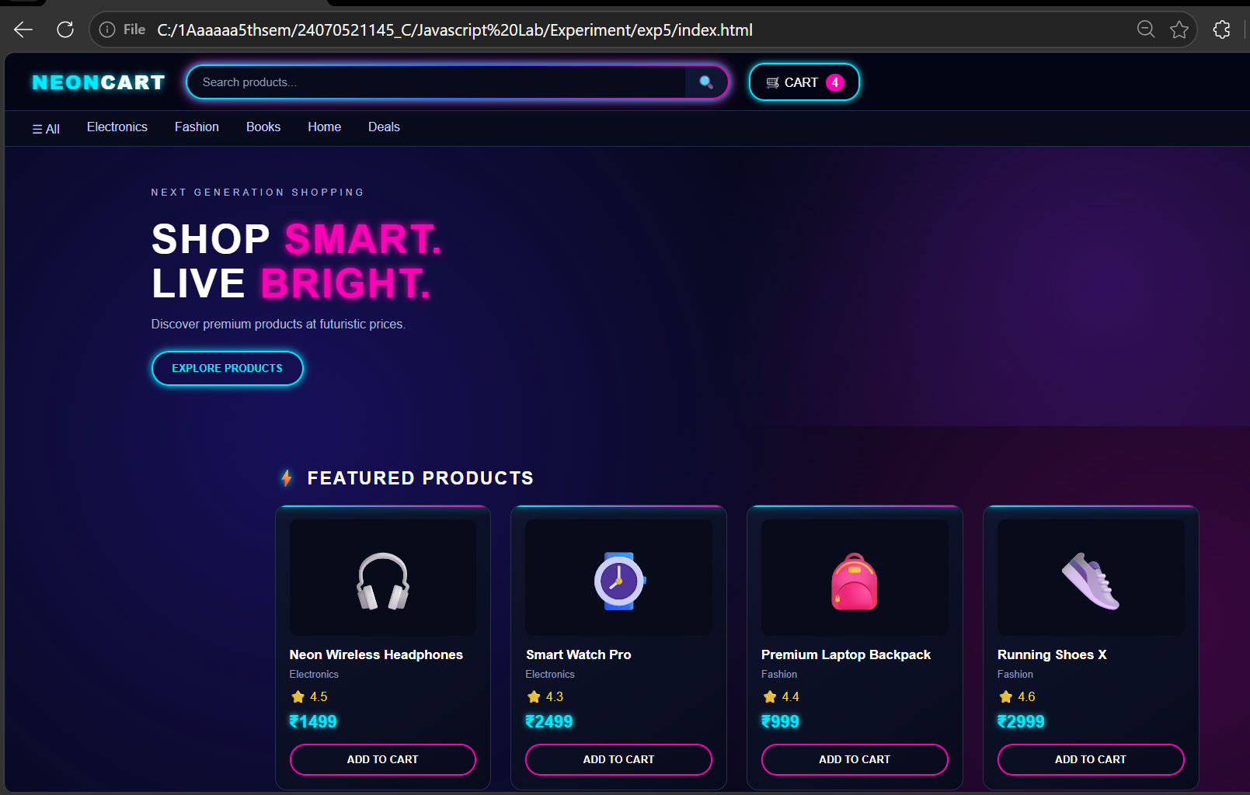
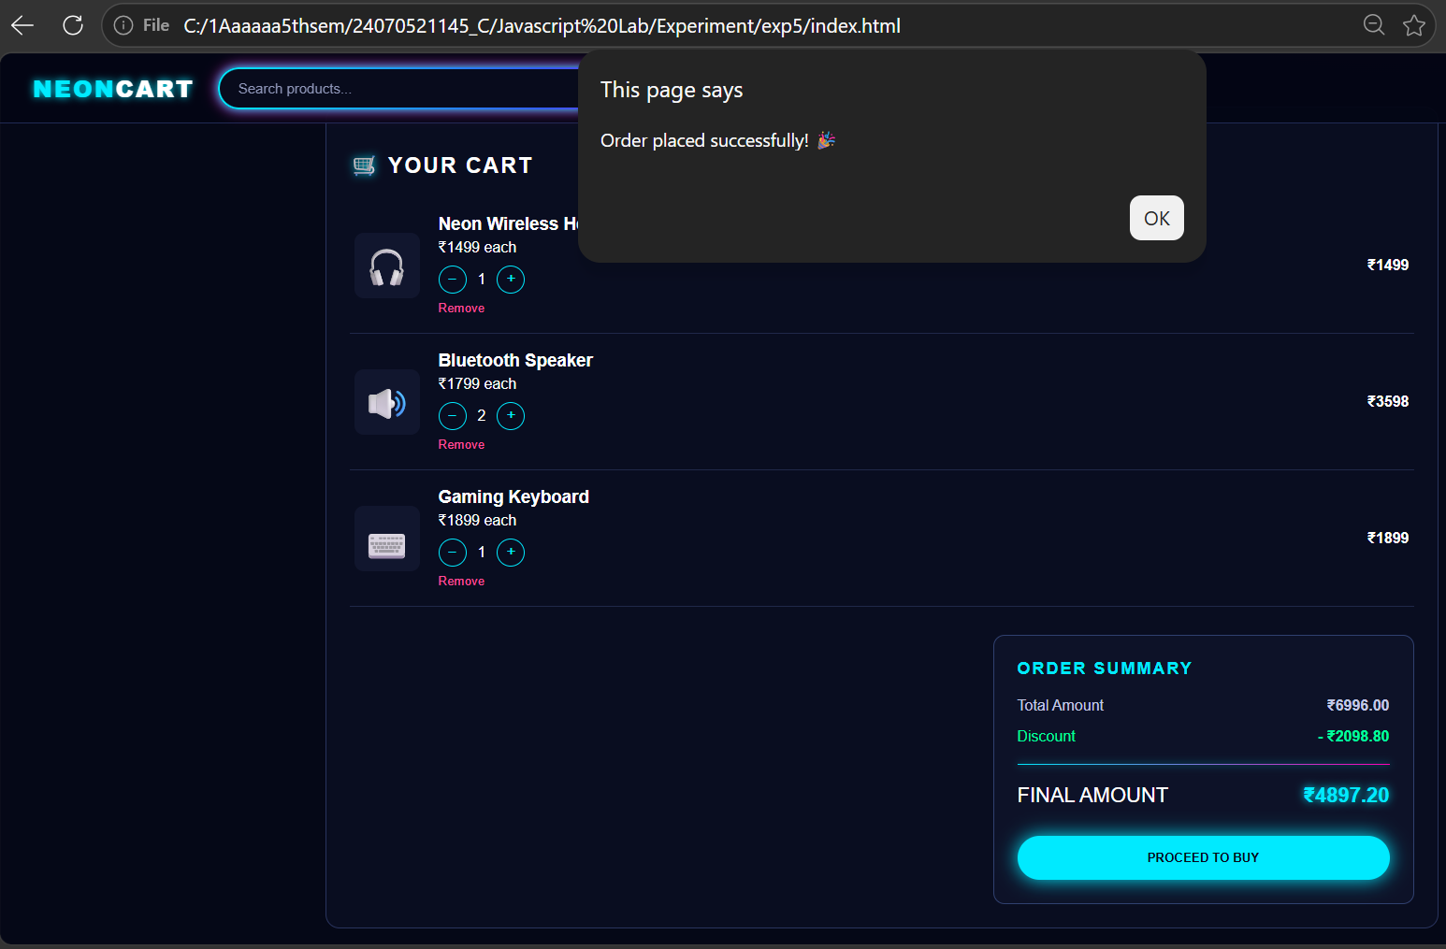
5.Result
The shopping cart application was successfully developed using HTML, CSS, and JavaScript. It provides an interactive e-commerce interface where users can browse products, search items, add or remove products, modify quantities, and view the cart summary. The application dynamically calculates the total amount, applicable discount, and final payable amount using JavaScript array methods and object handling.

